
ANNA UNIVERSITY REGIONAL CAMPUS, COIMBATORE - 641 041

DEPARTMENT OF ELECTRONICS AND COMMUNICATION ENGINEERING ACADEMIC YEAR 2023-2024 (SEMESTER 5)
IBM NAAN MUDHALVAN ARTIFICIAL INTELLIGENCE PROJECT 3: CREATE A CHATBOT IN PYTHON
PHASE 4: DEVELOPMENT PART 2

PRESENTED BY

RADHA DEVI M S

710021106302
CONTINUE BUILDING THE CHATBOT INTEGRATING IT INTO A WEB APP USING FLASK

STEPS TO FOLLOW THE PROCEDURE TO CREATE WEB APP USING FLASK:

STEP:1 Install the visual studio code and python latest version.

STEP:2 Install required libraries and extension in the visual studio code

STEP:3 Create the folder in the system and open the folder in the visual studio code and install the virtual env in the vs code.

STEP:4 Install required libraries to import the code in the vs code application.

STEP:5 create a code for the integrating the chatbot in the web applications.

STEP1:
Install the visual studio code and python latest version.
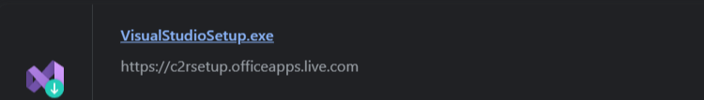

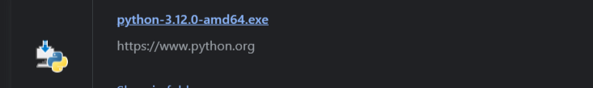

STEP 2:
Install required libraries and extension in the vs code

Libraries for the flask are

1.pip install flask
2.pip install flask-login
3.pip install nltk
4.pip install transformer
5.pip install torch’

Extension for web app create in vs code:

1.Flask
2.torch
3.python
4.transformer
5.nltk

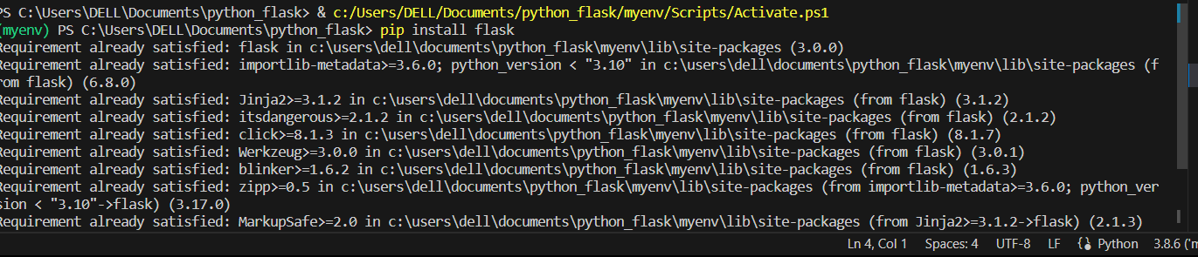
Libraries

Extension
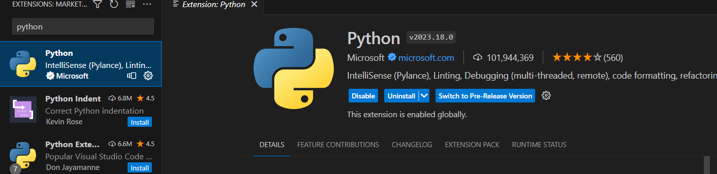

STEP 3:
Create the folder in the system and open the folder in the vscode and install the virtual env in the vs code.

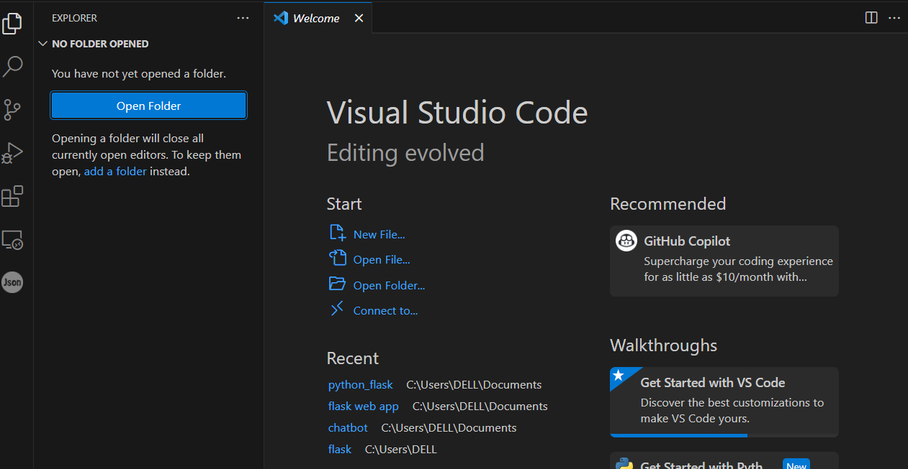

Install the virtualenv in the vs code:

Python -m venv -create the virtaulenv in the Terminal in the vscode

Venv file in the folder and activate the scripts in the folder for this application.

Venv\Scripts\activate- virtualenv terminal code.

Venv virtualenv created in that folder.
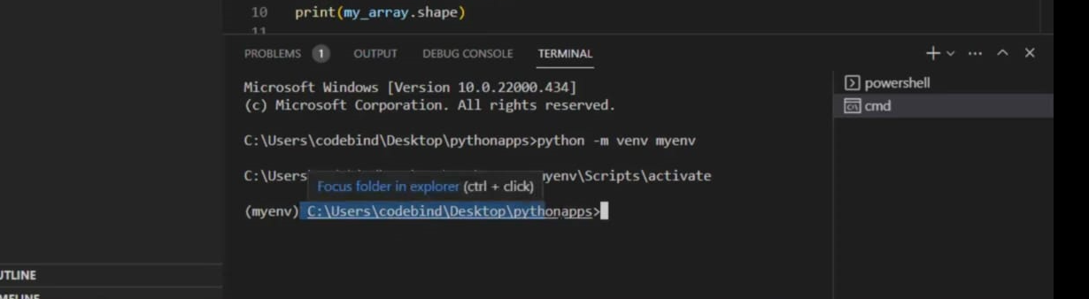
create a code for the integrating the chatbot in the web applications:

- Files are saved in app.py (python format):
- Create the web design html code and the images in the code in vs code
- In the code was successfully in the terminal display the localhost address for the web application output check
- The follow the localhost the travel the web application to access the chatbot users.
- Integrating the chatbot to the web using flask
- The chatbot receive the message from user and response through the bot.
- The dataset attached the file in this project

Local host: http://127.0.0.1:5000

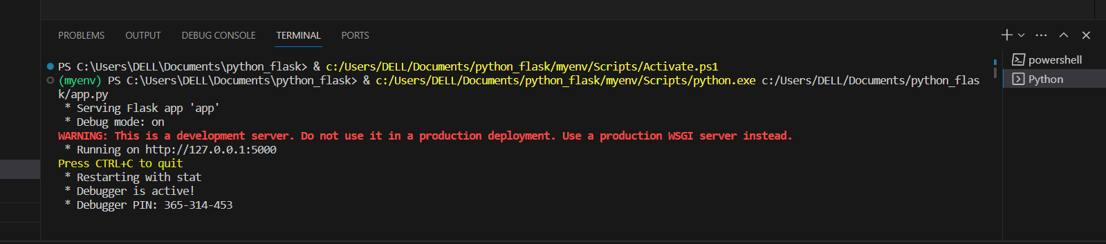
The localhost are the followed link to the web page.

The localhost are follow link are go to the web page

- The static file have the json file in the flask application
- The templates are have the web page file base.html file in the templates.
- The base.html file are run the web page in the localhost
- Localhost follow this web page link.

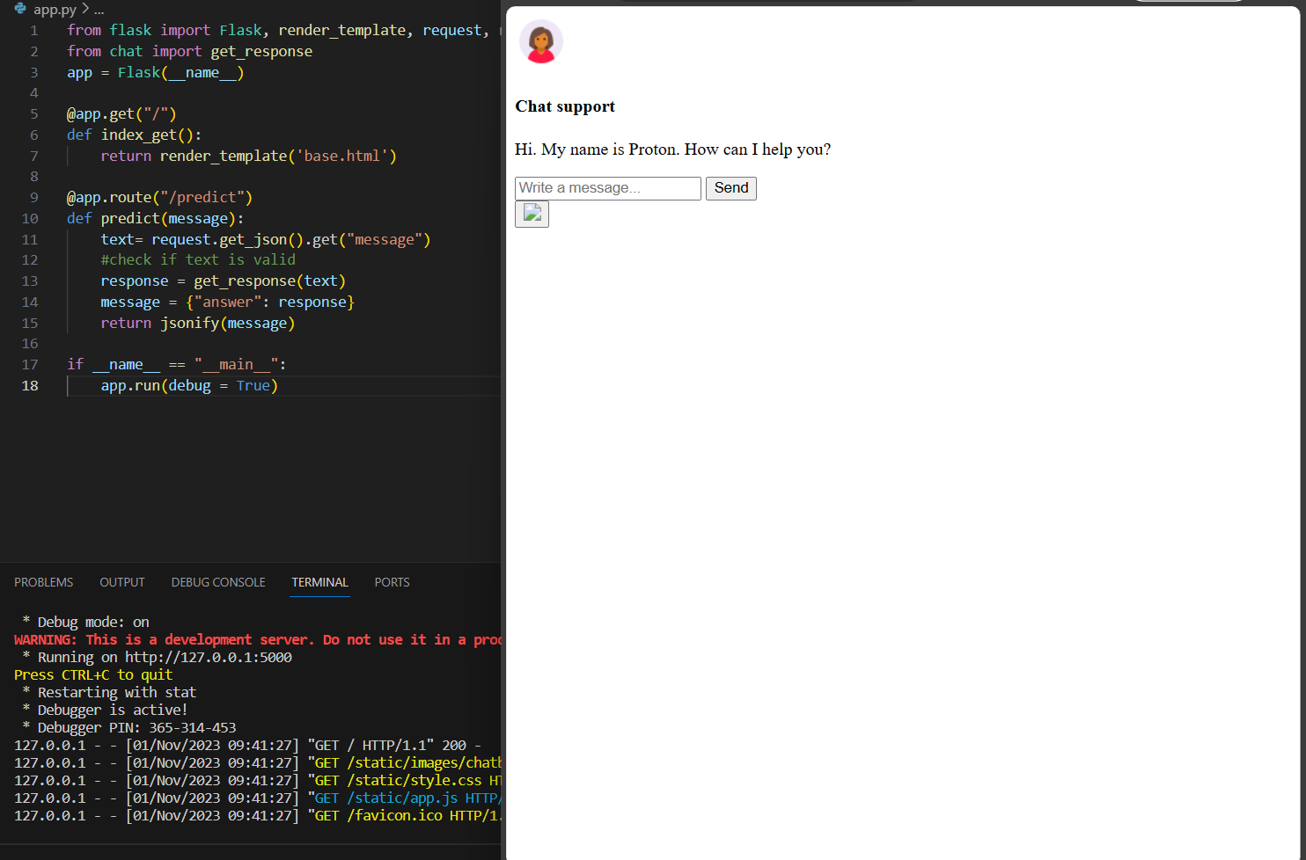
The above image are follow link of webpage integrating the chatbot to the website.

PROGRAM:

App.py code:
from flask import Flask, render_template, request, redirect, url_for, flash,jsonify
from chat import get_response
app = Flask(__name__)
@app.get("/")
def index_get():
return render_template('base.html')
@app.route("/predict")
def predict(message):
text= request.get_json().get("message")
#check if text is valid
response = get_response(text)
message = {"answer": response}
return jsonify(message)
if __name__ == "__main__":
app.run(debug = True)

NLTK.UTILITIES CODE:
mport nltk
#nltk.download('punkt') #uncomment to download punkt package
from nltk.stem.porter import PorterStemmer
import numpy as np
#initialise stemmer
stemmer = PorterStemmer()
#define tokenisation function
def tokenize(sentence):
return nltk.word_tokenize(sentence)
#define stemming function
def stem(word):
return stemmer.stem(word.lower())
#define bag of words function
def bag_of_words(tokenized_sentence, all_words):
"""
sentence = ["hello", "how", "are", "you"]
words = ["hi", "hello", "I", "you", "bye", "thank", "cool"]
bag = [ 0, 1, 0, 1, 0, 0, 0]
"""
tokenized_sentence = [stem(w) for w in tokenized_sentence]
bag =np.zeros(len(all_words), dtype=np.float32)
for idx, w in enumerate(all_words):
if w in tokenized_sentence:
bag[idx] = 1.0
return bag

Chat.PY:
import random
import json
import torch
from model import NeuralNet
from nltk_utilities import bag_of_words, tokenize
#check for gpu availability
device = torch.device('cuda' if torch.cuda.is_available() else 'cpu')
with open('intents.json', 'r') as json_data:
intents = json.load(json_data)
FILE = "data.pth"
data = torch.load(FILE)
input_size = data["input_size"]
hidden_size = data["hidden_size"]
output_size = data["output_size"]
all_words = data['all_words']
tags = data['tags']
model_state = data["model_state"]
model = NeuralNet(input_size, hidden_size, output_size).to(device)
model.load_state_dict(model_state)
model.eval()
bot_name = "Proton"
def get_response(msg):
sentence = tokenize(msg)
X = bag_of_words(sentence, all_words)
X = X.reshape(1, X.shape[0])
X = torch.from_numpy(X).to(device)
output = model(X)
_, predicted = torch.max(output, dim=1)
tag = tags[predicted.item()]
probs = torch.softmax(output, dim=1)
prob = probs[0][predicted.item()]
if prob.item() > 0.75:
for intent in intents['intents']:
if tag == intent["tag"]:
return random.choice(intent['responses'])
return "I do not understand..."
if _name_ == "_main_":
print("Let's chat! (Type 'quit' to exit)")
while True:
# sentence = "do you use credit cards?"
sentence = input("You: ")
if sentence == "quit":
break
resp = get_response(sentence)
print(resp)

HTML CODE:
<!DOCTYPE html>
<html lang="en">
<link rel="stylesheet" href="{{ url_for('static', filename='style.css') }}">
<head>
<meta charset="UTF-8">
<title>Chatbot</title>
</head>
<body>
<div class="container">
<div class="chatbox">
<div class="chatbox__support">
<div class="chatbox__header">
<div class="chatbox__image--header">
<img src="https://img.icons8.com/color/48/000000/circled-user-female-skin-type-5--v1.png" alt="image">
</div>
<div class="chatbox__content--header">
<h4 class="chatbox__heading--header">Chat support</h4>
<p class="chatbox__description--header">Hi. My name is Proton. How can I help you?</p>
</div>
</div>
<div class="chatbox__messages">
<div></div>
</div>
<div class="chatbox__footer">
<input type="text" placeholder="Write a message...">
<button class="chatbox__send--footer send__button">Send</button>
</div>
</div>
<div class="chatbox__button">
<button><img src="{{ url_for('static', filename='images/chatbox-icon.svg') }}" /></button>
</div>
</div>
</div>
<script>
$SCRIPT_ROOT = {{ request.script_root|tojson }};
</script>
<script type="text/javascript" src="{{ url_for('static', filename='app.js') }}"></script>
</body>
</html>

Train.py
#import necessary libraries
import json
from nltk_utilities import tokenize, stem, bag_of_words
import numpy as np
import torch
import torch.nn as nn
from torch.utils.data import Dataset, DataLoader
from model import NeuralNet
#import json file and open it
with open('intents.json') as f:
intents = json.load(f)
#tokenisation
all_words = []
tags = []
xy = []
for intent in intents['intents']:
tag = intent['tag']
tags.append(tag)
for pattern in intent['patterns']:
w = tokenize(pattern)
all_words.extend(w)
xy.append((w,tag))
#ignore the following words
ignore_words = ['?', '!', '.', ',']
#stemming
all_words = [stem(w) for w in all_words if w not in ignore_words]
all_words = sorted(set(all_words))
tags = sorted(set(tags))
print(tags)
#training data
X_train = []
y_train = []
for (pattern_sentence, tag) in xy:
bag = bag_of_words(pattern_sentence, all_words)
X_train.append(bag)
label = tags.index(tag)
y_train.append(label)
X_train = np.array(X_train)
y_train = np.array(y_train)
#build pytorch dataset
class ChatDataset(Dataset):
def __init__(self):
self.n_samples = len(X_train)
self.x_data = X_train
self.y_data = y_train
#dataset[idx]
def __getitem__(self, index):
return self.x_data[index], self.y_data[index]
def __len__(self):
return self.n_samples
#hyperparameters
batch_size = 8
hidden_size = 8
output_size = len(tags)
input_size = len(X_train[0])
learning_rate = 0.001
num_epochs = 1000
dataset = ChatDataset()
train_loader = DataLoader(dataset=dataset, batch_size=batch_size, shuffle=True, num_workers=0)
#check for gpu support
device=torch.device('cuda' if torch.cuda.is_available() else 'cpu')
model = NeuralNet(input_size, hidden_size, output_size).to(device)
#loss and optimiser
criterion = nn.CrossEntropyLoss()
optimizer = torch.optim.Adam(model.parameters(), lr=learning_rate)
#training loop
for epoch in range(num_epochs):
for (words, labels) in train_loader:
words=words.to(device)
labels=labels.to(device)
#forward prop
outputs = model(words)
loss = criterion(outputs, labels.long()) #long dtype is expected for crossentropyloss
#backward prop and optimisation
optimizer.zero_grad()
loss.backward()
optimizer.step()
if (epoch+1)%100 == 0:
print(f'epoch {epoch+1}/{num_epochs}, loss={loss.item():.4f}')
print(f'final loss, loss={loss.item():.4f}')
data ={
"model_state": model.state_dict(),
"input_size": input_size,
"output_size": output_size,
"hidden_size": hidden_size,
"all_words": all_words,
"tags": tags
}
FILE = "data.pth"
torch.save(data, FILE)
printf('Training complete. File saved to {FILE}')
the code for the chatbot interfacing with web page application the above codes created in the flask.

